**01. Introduction to AWS Load Balancer Controller**

--- in this lecture I am going to install aws load balancer controller on AWS EKS cluster. This is the core controller which helps us to create the ingress services in kubernetes cluster.

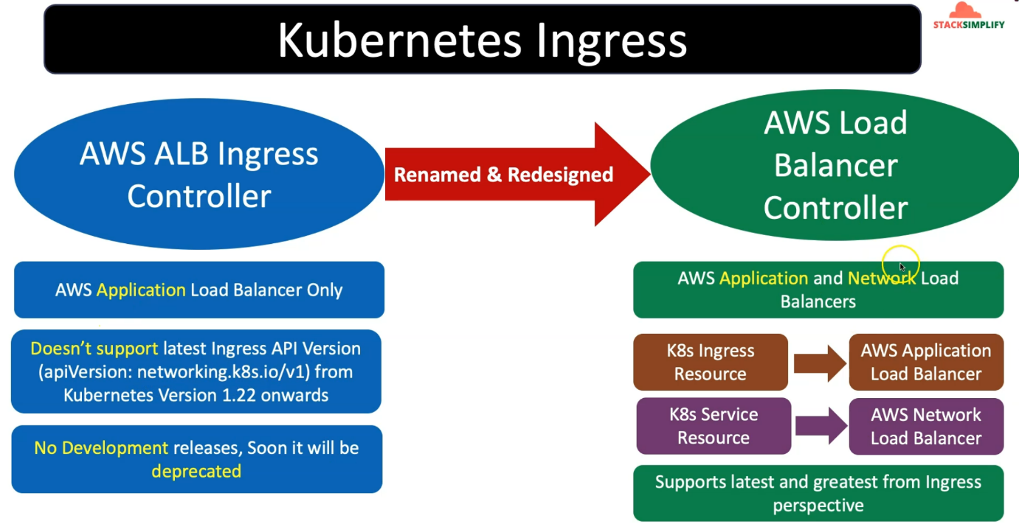

--- from kubernetes ingress perspective, earlier AWS used to have AWS ALB ingress controller and that is renamed and redesigned now as AWS load balancer controller.

--- earlier it is used to create AWS application load balancer resources on AWS from EKS cluster. So, when you deploy an ingress controller, it will create application load balancer in AWS but now as part of the AWS load balancer controller, it can create application load balancer and network load balancer.

--- for creating the application load balancer, we are going to use the kubernetes object name k8s ingress resources

--- for creating the network load balancer, we are going to use the kubernetes type service

**How the load balancer works**

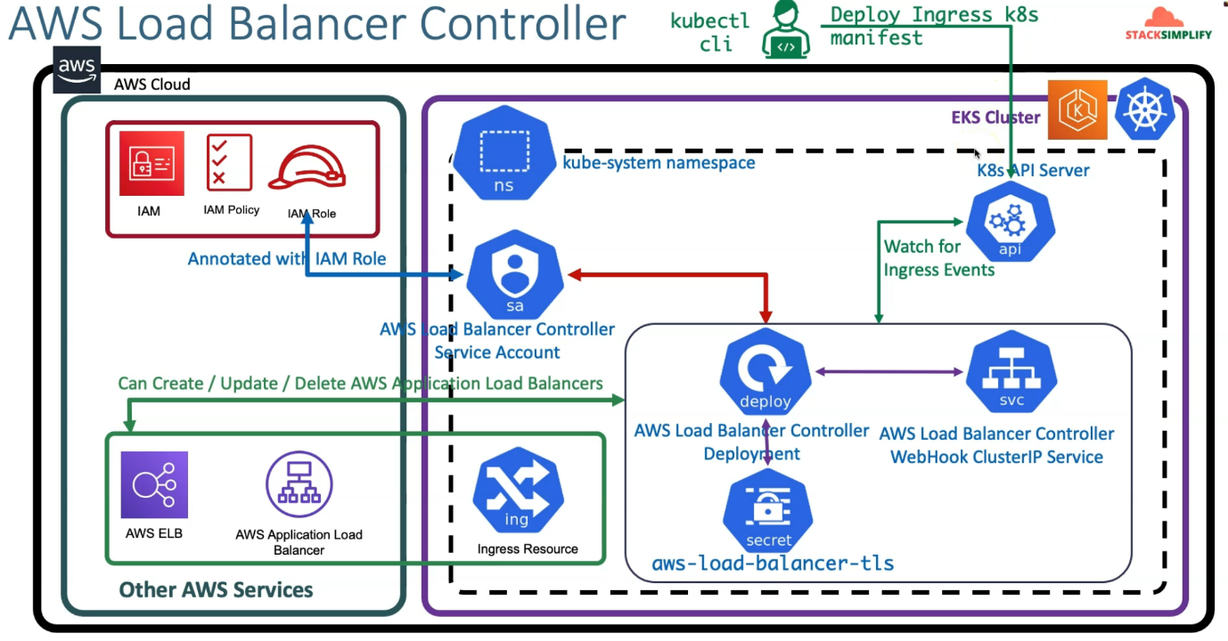

--- **note** - What all the objects’ involved from the kubernetes for this load balancer controller. Let this is a visual manner.

--- if you see here in the EKS cluster, we have something called Kube System Namespace and in AWS cloud other AWS services will be created here. Inside of this name space, Load Balancer controller resources will be created.

--- So, to start with that very important point here is AWS Load Balancer controller related service account in Kubernetes and will create this service account and also will create the IAM policy and then I am role.

--- this I am role will be annotated inside this service account; this I am role **ARN** will be annotated inside this Lode balancer controller service account.

--- Next thing here is so whenever you deploy your Load Balancer controller, it will create a deployment, which eventually created pods related to this load balancer controller.

--- in addition to that, it will also create a load balancer controller webhook cluster IP service, and it will also create AWS load balancer TLS secret. So, these are the things which are involved from Kubernetes perspective in Kube system namespace.

--- this service account, whatever we have created, is associated with this deployment, which means it is also associated with the pods, so this load balancer controller gets the ability to create the application load Balancer or Network Load Balancer from EKS cluster in AWS cloud.

--- in every EKS cluster OR any Kubernetes cluster, we know that we'll have the Kubernetes API server. So, as a Kubernetes administrator. what I'm going to do is I'm going to use the kubectl CLI, iam going to deploy the kubernetes ingress manifest.

--- this load balancer controller will watch for that ingress events on this Kubernetes API server and whenever it finds this kubernetes ingress manifest is deployed, so this load balancer controller will take that manifest and go ahead and then create the application load balancer for us.

--- from AWS perspective, you can see that as application load balancer and in Kubernetes, you can see that as a ingress resource. So, this is what is going to happen whenever we deploy a simple ingress service manifest.

--- inside of this load balancer, we have worker nodes and inside of the worker nodes we have pods.

--- **note** - we have created a IAM policy, which has the permissions to create application load balancer related resources or update the resources are delete the resources related to application load balancer.

--- **note** - I am policies associated with this IAM role. I am role is annotated with the AWS Load Balancer Controller Service account and this service account is used by this load balancer controller deployment related pods due to that from EKS cluster itself, we are able to create the AWS application load balancer whenever we have deployed the Ingress k8s manifest.